Homework 4: 100 Points
This Homework contains examples on the features of modern microarchitecture: Prediction, Speculation, multiple issue, dynamic scheduling, and Out-of-Order Execution.
Please submit your answers in an MS Word document and upload it in Canvas by the due date. I
Present your work neat, clear, organized, logical, and make your case; don’t leave it to our interpretation of your answer. There is 10% penalty per day for delay in submitting the homework.
- (10 Points) Suppose the following code is within a loop reading the values of x. Assume a Branch History Table of 1-bit predictor used. Use a table to show the content of the predictor buffers as values of x: 12, 18, 23, 40, 42, 44, 46, 48, 50 are read. Assume the two predictor buffers contain 0 and 1 initially.
If (x is odd) then ;Branch B1
print “O”
if (x is even) then ;Branch B2
print “E”
Calculate the prediction accuracy of this predictor.

Value | Odd or Even | Predictor | Branch | Is It Right? | Updated Predictor
12 | Even | 0 | B2 | Yes | 0
18 | Even | 0 | B2 | Yes | 0
23 | Odd | 0 | B1 | No | 1
40 | Even | 1 | B2 | No | 0
42 | Even | 0 | B2 | Yes | 0
44 | Even | 0 | B2 | Yes | 0
46 | Even | 0 | B2 | Yes | 0
48 | Even | 0 | B2 | Yes | 0
50 | Even | 0 | B2 | Yes | 0
Accuracy= 7/9= 0.77…

- (10 Points) Answer Problem 1 using a Branch History Table of 2-bit predictor. Assume the two predictor buffers contain 10 and 10 initially.

Value | Odd or Even | Predictor | Prediction | Actual | Is It Right? | Updated Predictor
12 | Even | 10 | Taken | Taken | Yes | 11
18 | Even | 11 | Taken | Taken | Yes | 11
23 | Odd | 10 | Taken | Not Taken | No | 01
40 | Even | 11 | Taken | Taken | Yes | 11
42 | Even | 11 | Taken | Taken | Yes | 11
44 | Even | 11 | Taken | Taken | Yes | 11
46 | Even | 11 | Taken | Taken | Yes | 11
48 | Even | 11 | Taken | Taken | Yes | 11
50 | Even | 11 | Taken | Taken | Yes | 11
Accuracy= 8/9= 0.88…

- (10 Points) Suppose the following loop iterates 99 times. Assume a 1-bit predictor is used. Calculate the prediction accuracy of this predictor. Assume the buffer contains 0 initially.
Loop: LD F1, 0(R1)
……
……
BNEZ R2, Loop

Iteration(s) | Predictor | Actual | Is It Right? | Updated
1 | 0 | Taken | No | 1
2 | 1 | Taken | Yes | 1
3-98 | 1 | Taken | Yes | 1
99 | 1 | Not Taken | No | 0
Accuracy= 97/99= 0.9797…

- (10 Points) Answer Problem 3 using a 2-bit predictor. Assume the buffer contains 00 initially.

Iteration(s) | Predictor | Actual | Is It Right? | Updated
1 | 00 | Not Taken | No | 01
2 | 01 | Not Taken | No | 10
3 | 10 | Taken | Yes | 11
4-98 | 11 | Taken | Yes | 11
99 | 11 | Not Taken | No | 10
Accuracy= 97/99= 0.9797…

- (12 Points) Consider the code in Example 4, Chapter 3 slides. Assume a ten entry Branch History Table of 2-bit predictor used with initial values of 01. Show the prediction behavior if the following are read into the code via a loop:
aa=3 and bb=2, followed by aa=4 and bb=5, followed by aa=2 and bb=2
Calculate the overall prediction accuracy.

Branch | Value | Predictor | Actual | Is It Right? | Updated
b1 | aa=3 | 01 | Not Taken | Yes | 01
b2 | bb=2 | 01 | Taken | No | 10
b3 | aa not equal to bb | 01 | Taken | No | 10
b1 | aa=4 | 01 | Not Taken | Yes | 01
b2 | bb=5 | 10 | Not Taken | No | 01
b3 | aa not equal to bb | 10 | Taken | Yes | 11
b1 | aa=2 | 01 | Taken | No | 10
b2 | bb=2 | 01 | Taken | No | 10
v3 | aa=bb | 11 | Not Taken | No | 10
Accuracy= 3/9= 0.33…

- (12 Points) a) Display a Branch Target Buffer for the code in Example 6. Assume 1- bit predictor for branches are initially 1, 0, 1.

Branch Address | Predictor PC | Predictor Bit
2012 | 202 | 1
2036 | 2064 | 1

  - Now assume you execute the code again and this time all three branches are taken. Display the new BTB.

Branch Address | Predictor PC | Predictor Bit
2012 | 2020 | 1
2024 | 2032 | 1
2036 | 2064 | 1

- (12 Points) State what takes place when each of the following instructions reach the top of ROB and their operands are all available:
  - L.D F2, 0(R6)
  - ADD.D F2, F4, F6
  - S.D F2, 0(R2)
  - DSUBU R3, R3, #-8
  - BNEZ R3, target (Predicted Correctly)
  - BEQZ R3, Loop (Mispredicted)

Instruction | Action at Top of ROB
L.D F2, 0(R6) | Value is written to F2- instruction commits.
ADD.D F2, F4, F6 | Result is written to F2- instruction commits.
S.D F2, 0(R2) | Value in F2 is stored to memory- store executes and instruction commits.
DSUBU R3, R3, #-8 | Result is written to R3- instruction commits.
BNEZ R3, target | Prediction was correct- branch commits and control flow continues normally
BEQZ R3, Loop | Prediction was wrong- flush previous instructions and update PC to correct target (ie the loop)

- (12 Points) Exercise 3.1 of textbook.

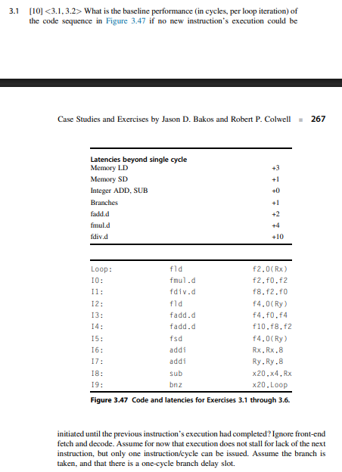
Line | Instruction | Latency
0 | fld f2, 0(Rx) | 4
1 | fmul.d f2, f0, f2 | 5
2 | fdiv.d f8, f2, f0 | 11
3 | fld f4, 0(Ry) | 4
4 | fadd.d f4, f0, f4 | 3
5 | fadd.d f10, f8, f2 | 3
6 | fsd f4, 0(Rx) | 2
7 | addi Rx, Rx, -8 | 1
8 | addi Ry, Ry, 8 | 1
9 | sub x20, x4, Rx | 1
10 | bnz x20, Loop | 2
4+5+11+4+3+3+2+1+1+1+2= 37 cycles

- (12 Points) Exercise 3.7 of textbook.
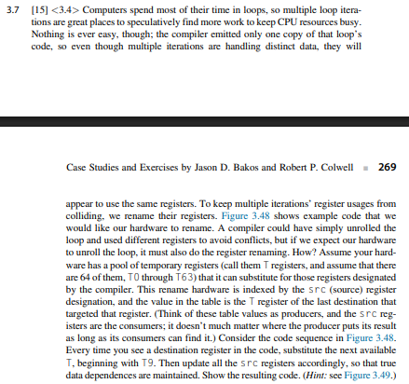

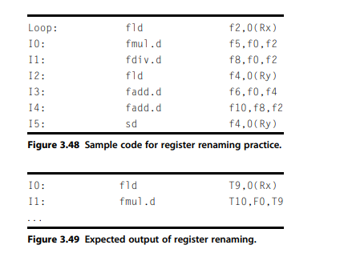

Original Instruction | Renamed Instruction | Key Changes
fld f2, 0(Rx) | fld T9, 0(Rx) | f2 -> T9
fmul.d f5, f0, f2 | fmul.d T10, f0, T9 | f5 -> T10, f2 = T9
fdiv.d f8, f0, f2 | fdiv.d T11, f0, T9 | f8 -> T11, f2 = T9
fld f4, 0(Ry) | fld T12, 0(Ry) | f4 -> T12
fadd.d f6, f0, f4 | fadd.d T13, f0, T12 | f6 -> T13, f4 = T12
fadd.d f10, f8, f2 | fadd.d T14, T11, T9 | f10 -> T14, f8 = T11, f2 = T9
sd f4, 0(Ry) | sd T12, 0(Ry) | f4 -> T12

